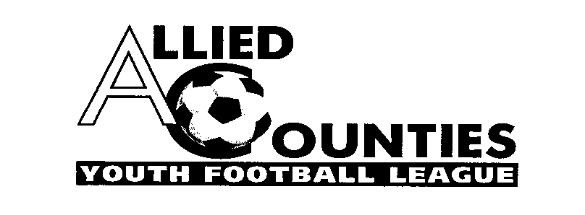
Official website www.acyfl.co.uk Twitter @ACYLofficial FA ACYL FULLTIME
Bulletin 40 – 2020/2021 14/05/2022
2022-2023 GROUDSHARES/D FORMS/AGREEMENTS
Any club intending to groundshare during next season must submit a fully completed groundshare document for approval by the ACYL when submitting the clubs D FORM and Agreement. The D FORM and Agreement will be sent to all member clubs on the 16th May to be returned no later than the 31st May. Any club who do intend to groundshare and who do not provide a fully completed groundshare agreement will have your league membership terminated.

AGM/CLUB WITHDRAWALS
The AGM will be held on Monday 20th June at Uxbridge FC at 8pm, consequently any club intending, or having a provisional intention, to withdraw from the league shall do so at least sixty (60) days before the AGM. Failure to comply with this result will result in a fine (not exceeding £100) in accordance with the Fines Tariff. That date was Thursday 21st April.

The LEAGUE CUP
FINAL at Ascot United FC on Sunday 15th May ko 2pm
North Greenford United v Flackwell Heath or Chalfont St Peter

The SUBSIDIARY CUP
FINAL at Chalfont St Peter FC on Thursday 19th May ko 7.45pm
Chalfont St Peter v Aldershot Town

The SUPPLEMENTARY CUP
FINAL at Harefield United FC on Wednesday 18th May ko 7.45pm
Hanwell Town v Wokingham & Emmbrook

LATEST RESULTS
Monday 9th May
SUBSIDIARY CUP SEMI FINAL
Aldershot Town 4-0 Frimley Green
SUPPLEMENTARY CUP SEMI FINAL
Hanwell Town 2-0 Didcot Town
Wednesday 11th May
CHAMPIONS CUP FINAL AT WINDSOR FC ko 7.45pm
Didcot Town 3-1 North Greenford United
SUBSIDIARY CUP SEMI FINAL
Westfield 3-6 Chalfont St Peter
Thursday 12th May
SUPPLEMENTARY CUP SEMI FINAL
Wokingham & Emmbrook v Hartley Wintney

BE AWARE FIXTURES AFTER THIS WEEK WILL LIKELY BE ARRANGED AT SHORT NOTICE, WE WILL ENDEAVOUR TO KEEP YOU INFORMED OF ARRANGEMENTS
FIXTURES going forward
Sunday 15th May
LEAGUE CUP FINAL AT ASCOT UNITED FC ko 2pm
North Greenford United v Flackwell Heath
Wednesday 18th MAY
SUPPLEMENTARY CUP FINAL
Hanwell Town v Wokingham & Emmbrook or Hartley Wintney (at Harefield United FC)
Thursday 18th May
SUBSIDIARY CUP FINAL
Chalfont St Peter v Aldershot Town (at Chalfont St Peter FC)

Alan King
General Secretary/Registrations/Results
07899 941414
generalsecretary@alliedcounties.co.uk
acylregistration@aol.co.uk

